**Send Mail Using SMTP Server**

# Setting the Gmail Account

First, we need to set up the Gmail Account with 2FA.

Right Click on the mail Icon and click on Manage Your Google Account.

On the Next Screen Click on the Security option and click 2-Step Verification .

Note : By Default, the 2-Step Verification IS off

Click On Get Started.

Give the Password for Gmail and click on next.

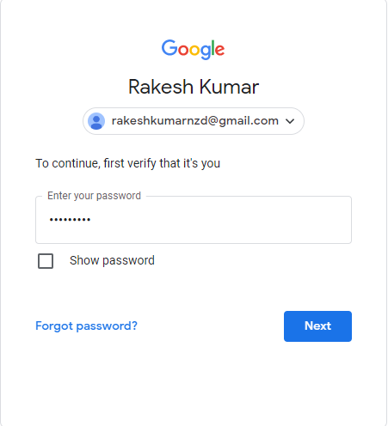

Click the Shown number in your mobile and Verify.

Click on Continue.

Enter Your Mobile Number and click on next

Give the OTP which is sent in the Mobile and click on Next.

9*********

Enter your OTP

Click on Turn On.

Again it prompt for the Gmail Password , give the Password and click on next.

Click on Turn ON.

In the Last step you will find an option App Passwords

Select the Other in the App

Give the Name to the App And click on Generate.

Your Password will be generated copy the password .

Note: Once You Close the window you are not able to see the password again So please save the password Somewhere.

Another way is to again create the App and regenerate and use that password.

Your Password Here

# Configuring axis2

Goto the <MI-HOME>/conf/axi2/axi2.xml file.

Add the following in the transport sender tags.

<transportSender name="mailto" class="org.apache.axis2.transport.mail.MailTransportSender">

<parameter name="mail.smtp.host">smtp.gmail.com</parameter>

<parameter name="mail.smtp.port">587</parameter>

<parameter name="mail.smtp.starttls.enable">true</parameter>

<parameter name="mail.smtp.auth">true</parameter>

<parameter name="mail.smtp.user">username</parameter>

<parameter name="mail.smtp.password">smtp password</parameter>

<parameter name="mail.smtp.from">emaild</parameter>

</transportSender>

Replace the username,smtp password,emailed with your credentials.

Add th below tag in transport receiver.

<transportReceiver name="mailto" class="org.apache.axis2.transport.mail.MailTransportListener">

Create a new Rest API .

Set a new Property as message type and the value = text/html.

Drag a payload mediator and give a tag as text.

Add a send mediator and inside the send mediator add a address mediator.

Give the mail id of whom you want to mail along with mailto: in the URL Section.

Export the API Artifact in the CAR File And Run the Server.

Go to the Post Man and see the response.

# Sample API Configuration Code.

<?xml version=*"1.0"* encoding=*"UTF-8"*?>

<api context=*"/smtpMail"* name=*"SMTP_Mail_API"* xmlns=*"http://ws.apache.org/ns/synapse"*>

<resource methods=*"GET"*>

<inSequence>

<log description=*"Welcome Log"*/>

<property description=*"text/html"* name=*"messageType"* scope=*"axis2"* type=*"STRING"* value=*"text/html"*/>

<payloadFactory media-type=*"xml"*>

<format>

<ns:text xmlns:ns=*"http://ws.apache.org/commons/ns/payload"*>

Hi Team this is a sample Mail to demonstrate how to send emails through email.

</ns:text>

</format>

<args/>

</payloadFactory>

<send>

<endpoint>

<address uri=*"mailto:ajay.akula@knotsolutions.com"*>

<suspendOnFailure>

<initialDuration>-1</initialDuration>

<progressionFactor>-1</progressionFactor>

<maximumDuration>0</maximumDuration>

</suspendOnFailure>

<markForSuspension>

<retriesBeforeSuspension>0</retriesBeforeSuspension>

</markForSuspension>

</address>

</endpoint>

</send>

</inSequence>

<outSequence/>

<faultSequence/>

</resource>

</api>

References: <https://apim.docs.wso2.com/en/latest/tutorials/integration-tutorials/using-the-gmail-connector/>